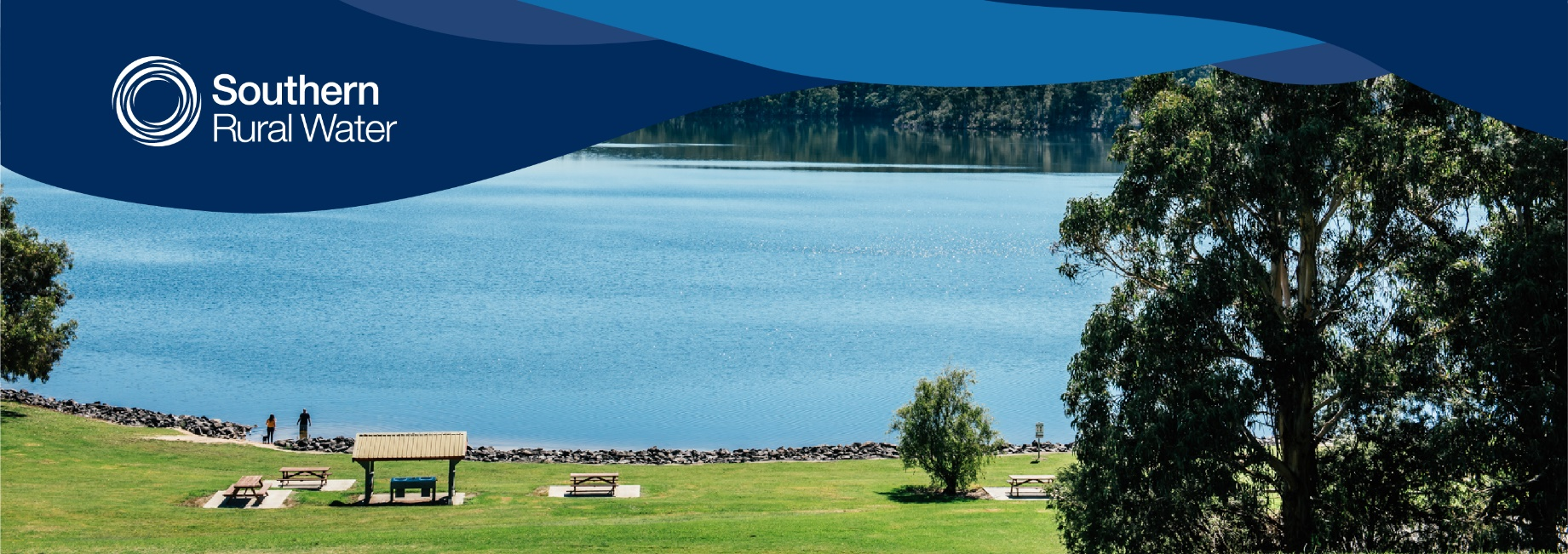

Sponsorship Application Form

Name:

Position:

Organisation:

ABN/CAN

Postal address:

Email:

Website (if available):

Sponsorship purpose:

What do you require sponsorship for?

Sponsorship

What amount or in-kind support are you requesting?

Please describe the objective of the Sponsorship:

Strengthen local community

Promote Sustainable environmental practice

Educate, particularly on water-related topics
Acknowledgement of sponsorship
Please outline how you will acknowledge Southern Rural Water’s sponsorship:

Other Information

Submit form
Submit your completed form:
Post to Southern Rural Water PO Box 153, Maffra, VIC 3860
Email: srw@srw.com.au
Questions
For further information on Southern Rural Water please visit our website: www.srw.com.au
If you have any further questions please contact us on 1300 139 510.

