
Yarram Groundwater Management Plan Annual Report

2015-16

Date - optional

Foreword

This report is submitted to the Minister for Water and West Gippsland Catchment Management Authority in accordance with s32C Water Act 1989. A copy of this report is available for inspection at the offices of the Authority, and notice of report availability of the report will be published as required by s32D of the Water Act 1989.

The purpose of this report is to detail Authority activities administering and enforcing the management plan, and provide information that is required to be reported under the Plan.

Area Summary

Area | Yarram Water Supply Protection Area
Segment | Groundwater
Area Declared | 4 November 2002
Plan Approved | 14 October 2010
Permissible Consumptive Volume | 25,690 ML
Scheduled Plan Review | A review will be undertaken in 2016
Implementation Authority | Southern Rural Water
Relevant CMA | West Gippsland Catchment Management Authority
Report Period | 1 July 2015 – 30 June 2016

1 Executive Summary 3
2 Introduction 4
3 Key Observations 6
3.1 Rainfall 6
3.2 Water Levels/flows 6
3.3 Salinity / Water Quality (If required under the plan) 8
3.4 Water Use 9
3.5 Non compliance 10
4 Plan Implementation 10
4.1 Monitoring 10
4.1.1 Prescriptions 10
4.1.2 Issues Affecting Implementation 11
4.2 Metering 11
4.2.1 Prescriptions 11
4.2.2 Metering activities 11
4.3 Restrictions on Licensing and Licence Transfers 12
4.3.1 Prescriptions 12
4.3.2 Compliance and Exceptions 13
4.3.3 Issues Affecting Implementation 13
4.4 Licensing Activities 13
4.4.1 Issues Affecting Implementation 13
5 Conclusions 13
6 Appendices 14
6.1.1 Appendix 1 - Hydrographs 14

Executive Summary

The Yarram Groundwater Management Plan (GMP) was prepared under Division 3 Part 3 of the Water Act 1989 for the Yarram Water Supply Protection Area (WSPA) and relates to the groundwater resources of the protection area. The Yarram GMP was approved by the Minister for Water in October 2010.

The objective of the management plan is to make sure that the water resources of the area are managed in an equitable manner so as to ensure the long-term sustainability of those resources.

Southern Rural Water (SRW) is the authority responsible for managing and administering the plan, which includes the preparation of an annual report to demonstrate compliance. The annual report summarises licence information, metered usage and monitoring data collected for the reporting period in accordance with the recommendations given in the Yarram GMP.

The Yarram GMP Annual Report for 2015-16 demonstrates that SRW has complied with the requirements of the plan.

SRW is currently reviewing the Yarram GMP to determine whether a groundwater management plan is still necessary or whether a local management plan would be more suitable. This is due for completion by the end of 2016.

Monitoring and metering indicate no significant changes in the condition of the resource or water usage patterns that require review of the plan. Therefore, it is considered that the groundwater resources of the Yarram WSPA are being managed sustainably.

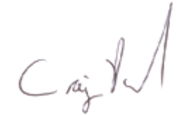

CRAIG PARKER
General Manager
Groundwater & Rivers

Introduction

This report summarises licence information, metered usage and monitoring data collected for the period between 1 July 2015 and 30 June 2016 in accordance with the recommendations given in the Yarram GMP.

The Yarram WSPA is located south of the Strezelecki Ranges and includes the on-shore area of the Gippsland Basin. This is a relatively small component of the whole Gippsland Basin but covers an area where groundwater is extracted primarily for irrigating pasture in Yarram and surrounding districts. The Yarram WSPA also incorporates forested areas along the Strzelecki Ranges comprising State Parks or plantation forestry.

It includes the aquifers in the Latrobe Group and the shallower Balook Formation which are the main sources of water used for irrigation. The Latrobe Group and Balook Formations are in hydraulic connection. From Woodside to Golden Beach, the Latrobe Group is much deeper, underlying the Gippsland Limestone and Boisdale Formations. These aquifers are overlain by the Haunted Hills Formation: a shallow unconfined aquifer, incised by local streams. It is low yielding and generally poorer quality than the other aquifers, and is typically suitable for stock watering and dairy wash purposes.

SRW has the duty of administering and enforcing the management plan.

The objective of a management plan, as set out in the Act, is to make sure that the water resources of the area are managed in an equitable manner so as to ensure the long-term sustainability of those resources.

The part that the management plan plays in ensuring long-term sustainability of the water resources is to prohibit the issue of any further groundwater licences. Restrictions are also placed on licence transfers within the WSPA.

The plan requires SRW to:

- Coordinate groundwater level monitoring and metering programs;
- Review monitoring and metering data;
- Administer groundwater licensing within the prescriptions of the plan;
- Review and report annually to the Minister administering the Water Act 1989 on the implementation of the plan;
- Seek review of the plan and if, in its opinion, amendments are necessary or desirable, make recommendations to the Minister accordingly.

The success of the Yarram GMP is measured through a number of licensing, metering and monitoring objectives.

- All consumptive use to be metered and recorded in line with both State Government and Corporation metering policies;
- Groundwater usage is to be maintained within licence volumes;
- Water levels and water quality (salinity) is to be monitored to maintain acceptable levels and to ensure the long term sustainable use of the aquifer(s);
- Trading of existing consumptive use allocations occurs in accordance with all relevant provisions of the Water Act 1989 and/or any supplementary rules adopted for the Yarram WSPA;
- No new groundwater licences will be issued if the total of all groundwater licence entitlements equal or exceed the PCV declared for the Yarram WSPA, unless in accordance with prescriptions 3 & 4.

Further information can be obtained from the Yarram WSPA Groundwater Management Plan. A copy can be found on Southern Rural Water’s website: www.srw.com.au.

Key Observations

Rainfall
Rainfall during the reporting period was 548.4mm (measured at Yarram Airport).
The average rainfall for this area is 732mm per year (which is measured at Yarram).
This area received approximately 180mm below the average for the reporting year.

Water Levels/flows
Groundwater levels are measured in fourteen (14) bores, monitoring the Haunted Hills, Latrobe Valley Coal Measures, and Latrobe aquifers.
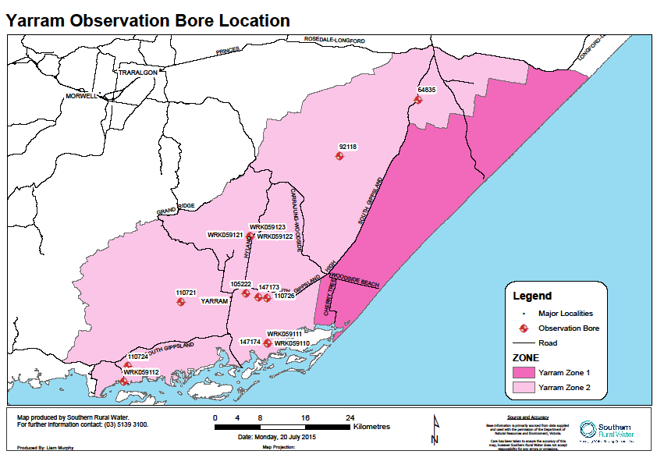
Figure 1: Map showing State Observation Bore locations.
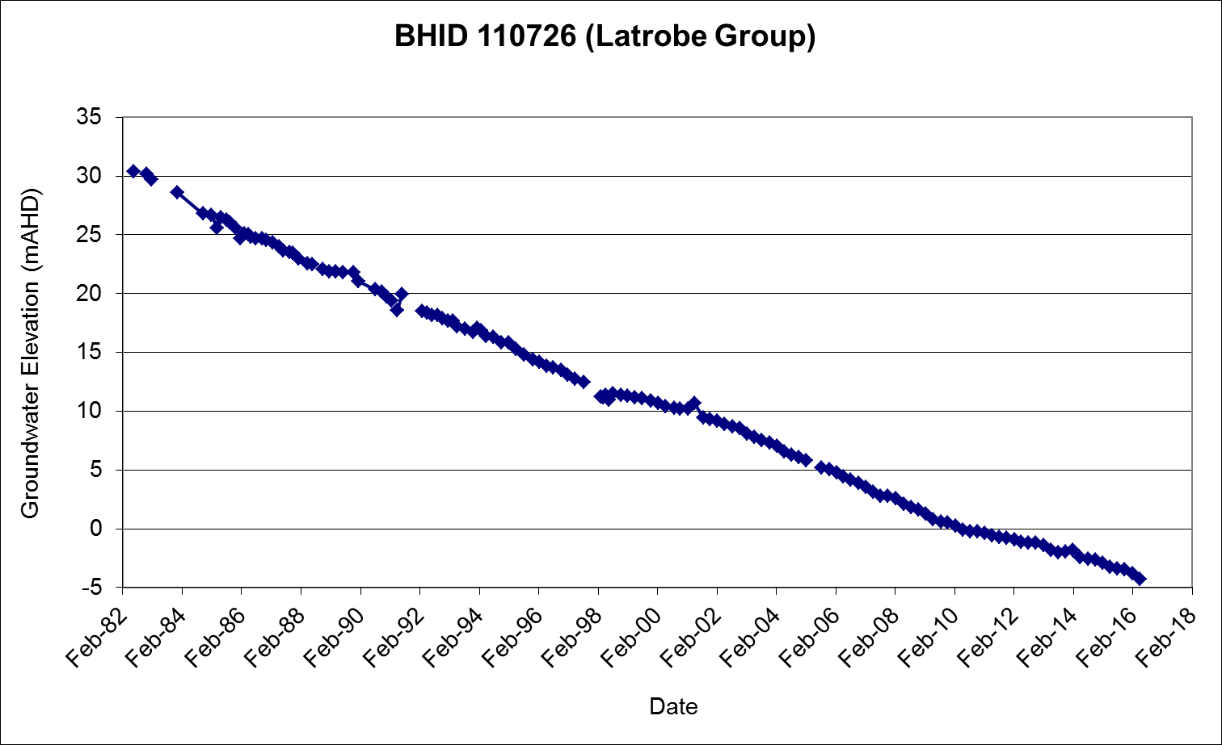
Figure 2: Example hydrograph
All hydrographs are presented in appendix 1.

The groundwater elevation data indicates that:
- Groundwater levels in the Latrobe aquifer are primarily influenced by offshore extraction. Levels have been falling steadily by approximately 1 meter per year since at least the early 1980’s.
- Some seasonal variance can be seen in bores 105222 and 110724, where groundwater extraction is concentrated. This extraction does not seem to influence the overall behavior of the aquifer.

Salinity / Water Quality
A monitoring program has been set up to take salinity measurements every twelve months from the same four private irrigation bores in Yarram. Currently, only two measurements have been taken, so no trends can be determined. This program was initiated in the December of 2014, and conducted by SRW personnel.

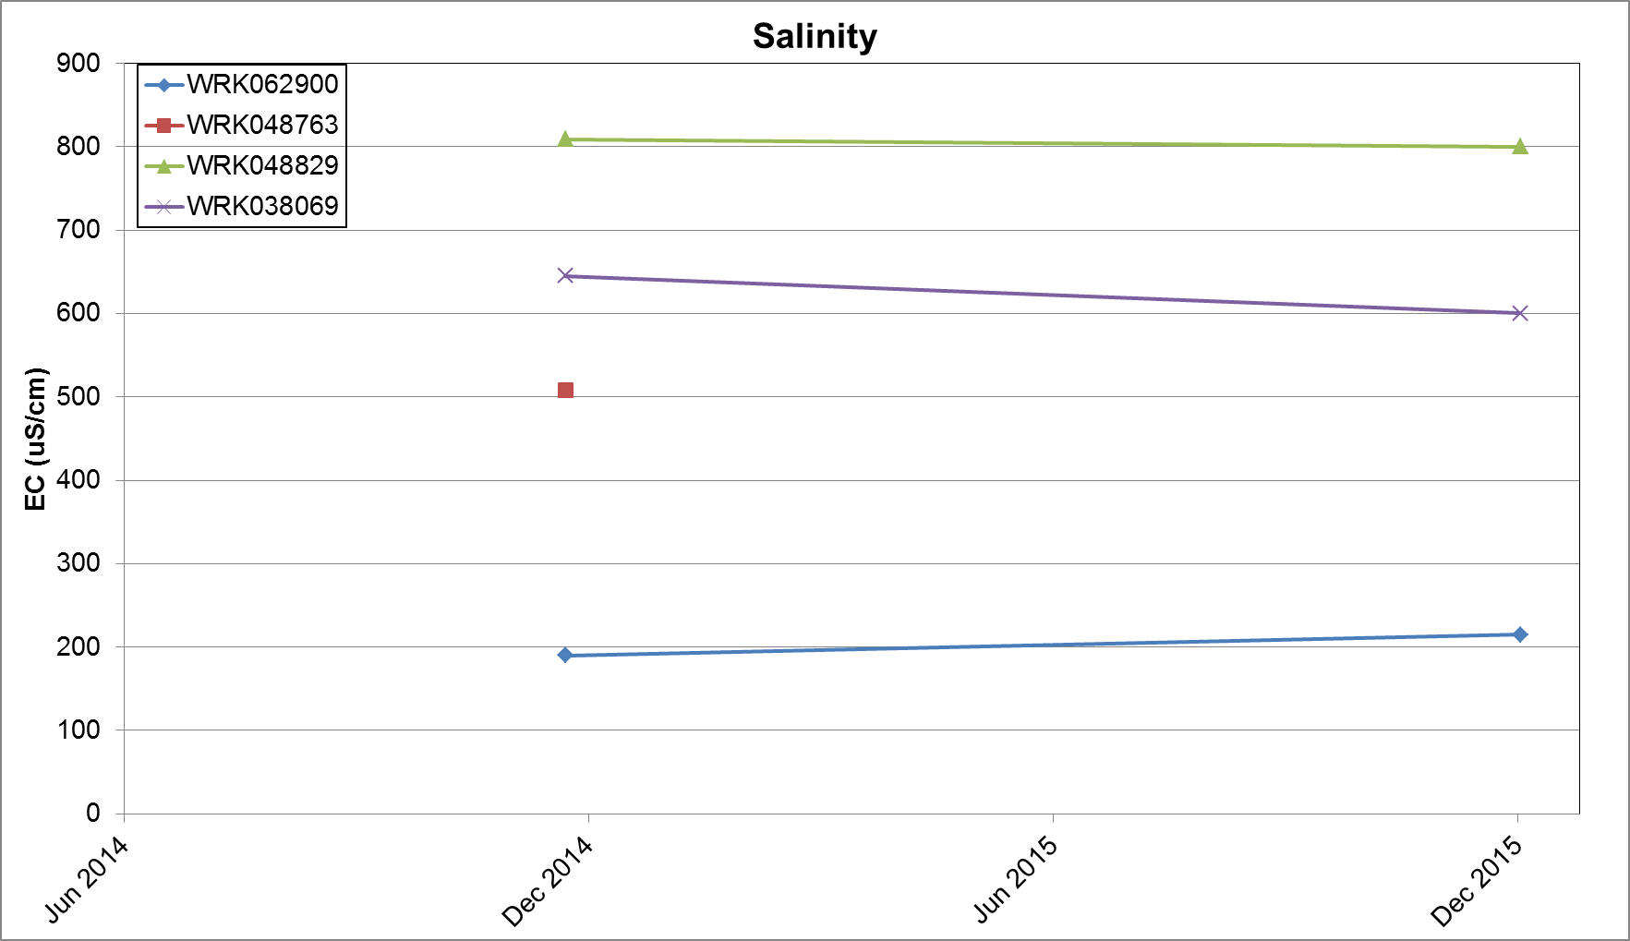

Water Use
The following table provides detail on water use in the 2015-16 year as compared to four previous years.

At 30 June | 2012 | 2013 | 2014 | 2015 | 2016
No. of licences | 92 | 91 | 90 | 86 | 87
Total allocated volume (ML) | 25,695.0 | 25,688.8 | 25,688.8 | 25,688.8 | 25688.8
No. of metered licences | 57 | 59 | 58 | 59 | 57
Total volume metered (ML) | 23,372 | 23,092 | 24,853 | 25,038 | 25,038
Metered volume used (ML) | 6,739.9 | 11,668.0 | 10,076 | 11,308.9 | 14,941
Use of allocation (%) | 26% | 45% | 39% | 44% | 58%
No. of licences with use greater than allocation (refer to section 3.5) | 1 | 2 | 0 | 0 | 3
Permissible Consumptive Volume (PCV) | 25,317.0 | 25,317.0 | 25,317.0 | 25,690.0 | 25,690.0
Use as a % of PCV | 27% | 46% | 40% | 44% | 58%
No. of D&S bores¹ | 324 | 320 | 291 | 285 | 285
D & S bores estimated use¹ | 486 | 480 | 437.0 | 428.0 | 428.0
Estimated D & S use from licensed bores² | 138 | 136.5 | 135.0 | 129 | 130.5
¹Taken from the Victorian Water Accounts
²Estimated 1.5ML per licence 2013 onwards
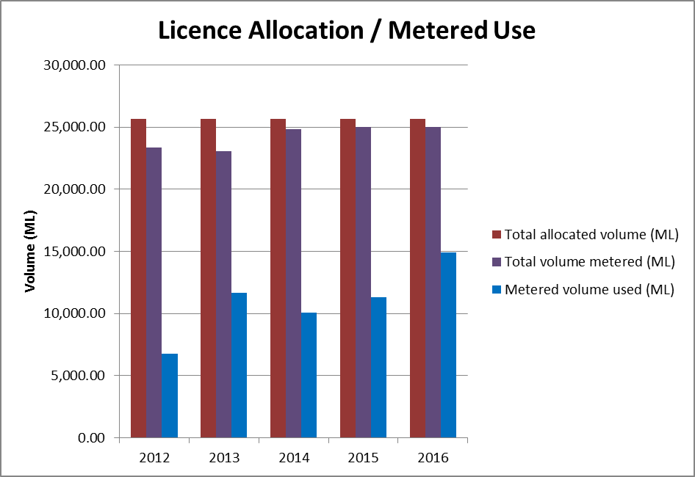
Figure 3: Licence allocation compared to metered volume and usage.

Compliance
The following table lists the licences where water was taken in excess of licensed entitlement.
Licence Number | Licence Volume | Amount taken | Amount overused | Comments
BEE021692 | 200 | 238.3 | 38.3 | Two licences were linked earlier in the year, however later separated, which showed an overuse on one licence.
BEE030848 | 421.2 | 453.1 | 31.9 | Warning letter sent.
BEE026817 | 1,108.5 | 1,183.8 | 75.3 | Has applied to amalgamate licences, and with stock and domestic allowance is over by around 2% of allocation.
Totals (ML) | 1,729.7 | 1,875.2 | 145.5

SRW investigates all compliance issues and considers several factors such as the seriousness of the breach and impact on the resource and other users, prior to deciding on the most appropriate action. The action taken by SRW can include the use of direction notices, warning letters and prosecution

Plan Implementation

Monitoring

Prescriptions
The following table details the requirements of the management plan in relation to monitoring.

Plan Requirement: | Activity / Reference | Complies
9. The Department must ensure that monitoring bores are properly maintained and replaced if necessary; and  10. The Department and the Corporation must ensure that data collected from monitoring bores is entered into the groundwater management system. | The monitoring bores are owned and managed by the Department of Environment Land Water and Planning (DELWP)  All bores have minor maintenance carried out annually which includes site clearance, rust removal, painting, and ensuring the bore is secure and safe.  The DELWP carries out maintenance on bores that have been identified by the field service provider through the Extra Works Advice. This is bore specific. | Yes  Yes
11. The Department and the Corporation must ensure that water level monitoring and investigations are carried out at appropriate locations throughout the Yarram WSPA to:  a) assess annual and long term impact on water levels from groundwater pumping;  b) monitor saline intrusion  c) monitor regional and local seasonal drawdown;  d) examine interaction between groundwater, surface water and groundwater dependent ecosystems;  e) provide information for future resource assessments; and  f) monitor the impacts of groundwater pumping generally across the Yarram WSPA and in areas of intensive groundwater pumping. | SRW works closely with the DELWP to ensure that the monitoring program meets the requirements of the Plan.  SRW regularly reviews the groundwater level program. (Covers section a, c, e and f)  If SRW identifies bores of greater interest, monitoring may be undertaken in addition to the DELWP’s monitoring program.  Refer to section 3.1.2 for further information on points 11b and 11d. | Yes

Issues Affecting Implementation
No issues affecting implementation.

Metering

Prescriptions
The plan does not have specific prescriptions relating to metering.

Active licence holders in the Yarram WSPA are metered in accordance with State Government policy and SRW requirements.

All meters are read at least twice per year in December/January and May/June. The meter readings and usage data are recorded and stored in SRW’s metering system.

Metering activities

 | Year to 30 June 2016 | Total for WSPA at 30 June 2016
Number of licences issued^{1,2} | 2 | 87
Number of meters installed | 1 | 89
Meters requiring maintenance | 12
Meters replaced | 0
Meters read (1 – date) | Jan 2016
Meters read (2 – date) | May/Jun 2016
Number of estimated readings | 0

¹New licence issued to allow part trade of existing entitlement
² New licence issued to allow for the division of an exiting entitlement
**This includes one meter that was removed as it was no longer required.

Restrictions on Licensing and Licence Transfers

Prescriptions
The following table details the requirements of the management plan in relation to licensing

Plan Requirement: | Activity/Reference | Complies
1. The Corporation must not approve an application for the permanent or temporary transfer of a licence under section 62 of the Act into the Coastal Zone. | No temporary transfers were processed during the reporting period. | Yes
2. The Corporation must not approve an application for the permanent transfer of a licence under section 62 of the Act into the Central Zone. | No permanent transfers were recorded transferring entitlement into the Central zone. | Yes
3. A new licence may be issued to overcome an administrative oversight or other anomaly or through a transfer of entitlement provided the PCV is not exceeded. | No activity to report. | Yes
4. The Corporation may issue or amend a groundwater licence in accordance with any state-wide policy and the PCV (by application to the Minister) will be adjusted accordingly. | Two new licences were issued to allow for a permanent transfer and splitting of an entitlement. The PCV was not affected. | Yes
5. The volume of any groundwater licence that is surrendered, revoked or not renewed, cannot be reallocated other than for the purposes of Prescriptions 3 and 4. | No activity to report. | Yes
6. No new licences are permitted in the Haunted Hills Formation. This applies to any applications to transfer into or within the Haunted Hills Formation. Exceptions may apply in accordance with Prescriptions 3 and 4. | No activity to report. | Yes
7. All groundwater licences within the Yarram WSPA will be migrated to the State Water Register within 6 months of ministerial approval of the Management Plan. | All licences are in the Water Register. | Yes
8. The Corporation must report the details of any licence referred to in Prescriptions 3 to 5 in the annual report on the administration and enforcement of the management plan required under section 32 of the Act. | Refer to appendices for licence details. | Yes

Compliance and Exceptions
Activities under taken during the reporting period comply with the requirements of the Plan.

Issues Affecting Implementation
No issues to report.

Licensing Activities
The following table provides details of licensing activities.

Year to 30 June 2015 | No. | Volume  ML
New licences issued | 2 | 0
Additional volumes on existing licences | 0 | 0
Licences revoked | 0 | 0
Permanent transfers | 1 | 12.0
Temporary transfers | 1 | 30.0
D&S Bores notifying use | 0 | 0

Issues Affecting Implementation
No issues to report.

Conclusions

The objective of a management plan, as set out in the Act, is to make sure that the water resources of the area are managed in an equitable manner so as to ensure the long-term sustainability of those resources.

It is considered that the groundwater resources of the Yarram WSPA are being managed sustainably.

SRW is currently reviewing the Yarram GMP to determine whether a groundwater management plan is still necessary or whether a local management plan would be more suitable. This is due for completion by the end of 2016.

Appendices

Licence details

Entitlement Number | Application Type | Purpose | Previous Volume | Approved Volume
BEE073626 | Issue¹ | Industrial or commercial | 0 | 12
BEE073749 | Issue² | Irrigation |  | 240.0
BEE023474 | Cancelled – Entitlement permanently transferred | Irrigation | 12 | 0
¹ Issued as part of an application to permanently transfer an existing entitlement
² Issued as part of an application to divide an existing entitlement

Appendix 1 - Hydrographs



